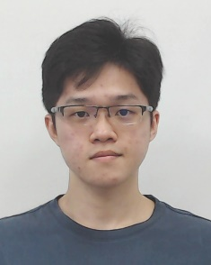**FOCS_StudF03: Student’s Progress Report**

Attached a photo here

(use digital photo)

**Tunku Abdul Rahman University College**

**Faculty of Computing and Information Technology**

**Industrial Training Progress Report**

Activity Log

|  |  |
| --- | --- |
| Name of Trainee: | Kong Mun Jun |
| Name of Company: | Ezee Technosys (M) Sdn Bhd |
| Month/Year: | January / 2022 |

|  |  |
| --- | --- |
| **Week** | **Projects / Activities** |
| **1** |  |
| **2** |  |
| **3** | On the first day, I had my orientation with my intern-mate to begin my internship journey in Ezee.  After familiar with the mission and objective of the company, we were given tasks to identify the difference between the budget hotels and luxury hotels from the case studies on how they apply system in their daily task.  Meanwhile, I volunteer myself to accept another task to clean the data for data import.  Last day of the week, Ezee had their Annual General Meeting which allow us to have the chance to know the strength of the company. They also proposed to have a intern talent show in the middle of the event. |
| **4** | Throughout the whole week, we were given task to identify the directory from the Ezee cloud system to simulate how hospitality staff run their daily task with.  At the same time, we were given lecture by our Leader, Ms. Gaka, in every detail function in the system. |

**Suggestions / Comments / Additional information (if any):**



**Leave Application / Leave Taken**

1. From (dd/mm/yyyy) ________________ to (dd/mm/yyyy) ______________ ( _______ days)

2. Reasons for taking leave:

3. Total number of days taken:_________________________________________________________

**I hereby declare that the information given above is correct.**

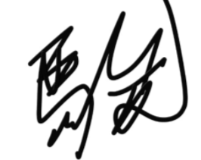

**Signature**: _____________________ **Date**: ___27/01/2021__

*(dd/mm/yyyy)*



|  |  |  |  |
| --- | --- | --- | --- |
| **Endorsement by the Company Supervisor:** | | | |
| **The above is a true record of activities taken by the trainee in the captioned week.** | | | |
| Signature of Supervisor: | __________________________ | | |
| Name of Supervisor: | __________________________ |  |  |
| Date: | *(dd/mm/yyyy)*_______________ |  |  |
| Email: | __________________________ |  |  |
| Mobile / Office Contact No.: | __________________________ |  |  |
| Company Stamp: | Company stamp with address |  |  |

